**Camunda BPM Training (5 Days)**

### Lab setup

### <https://camunda.com/download/enterprise/>

Camunda Enterprise platform Version:8

Using IDE IntelliJ/Eclipse

Docker desktop

Java 16/17 , springboot 3.x

Prerequisite

Participants should have good knowledge on Spring Boot 2.x and microservices patterns.

Recommendation

Highly recommended to have 6 days training because of additional topics.

**Day 1**

**Business Process Management Basics**

**Introduction to Camunda BPM**

**BPM & Process Automation**

* Process Modeling with BPMN 2.0
* Process Automation with BPMN 2.0
* Patterns and Best Practices
* Components Overview

**Day 2**

**Administration**

**Installing Camunda BPM**

* Integration into existing application server
* Database setup
* Sizing the production environment
* Clustering
* Performance tuning possibilities

**Operations**

* Monitoring the engine

# **DMN Training**

* Introduction into Decision Model & Notation, and Decision Tables
* Expressions with FEEL
* Hit Policies and Decision Design
* Decision Execution and Decision Engines
* DMN in the context of BPMN
* Complex Decisions with Decision Requirements Diagrams

Decision Flows

**Day 3**

# **Camunda BPM and Microservices**

* Process Modeling with BPMN 2.0
* Camunda BPM Platform
* Deploying to Camunda Engine
* Work with External Service Tasks
* Data Objects, Gateways & Expressions
* BPMN Event Handling
* Incident Handling
* Error Handling and Compensation
* Human Task Management
* Process Interaction
* Architecture
* Decoupling with Events
* Testing Processes
* Business Rules with DMN
* Camunda BPM Enterprise Edition
* Wrap up

**Process Engine**

* Shared vs. embedded Process Engine
* Process, Subprocess
* Deployment Scenarios
* Programming Model using CDI or Spring
* Process Data (Variables, XML, JSON) and Expression Language (JUEL, XPath)
* API (Java, REST, SOAP)
* Human Task Management
* Service Orchestration
* Runtime Service
* Task Service
* Repository Service
* Audit Service
* Management Service

**Operations**

* Gateways
* Events Handling (Timer, Message)
* Error Handling
* Exception Handling
* RollBack Scenarios
* Process Versioning
* Monitoring and Tooling

**Day 4**

**Process Applications**

* Unit Testing with JUnit and Arquillian
* Calling Services (Java, JMS, REST, SOAP, EMail)
* REST API – Invoking BPM Process
* REST API – security token handling
* REST API – process error handling

**Decision Management**

* What is Business Rules Management and a Rule Engine?
* Decision Management with DMN 1.0
* Integration of BPMN and DMN in Camunda BPM

**Day 5**

**Camunda BPM Advanced**

**Architecture**

* Embedded, Remote and Shared Process Engine
* Transaction Management

**Operations**

* Versioning of different components
* Deployment and Clustering
* Performance-Tuning

**Camunda BPM Docker / Open shift Deployment**

Docker tomcat camunda microservice war deployment

Docker camunda microservice jar deployment

Openshift Kubernete camunda microservice image deployment

Camunda Security

Security Configuration inside Camunda

Authentication

Enabling Authentication for the REST API

Authentication in the Web Applications

Internal (database backed) User Management

Enabling SSL / HTTPS

Error handling

Best Practices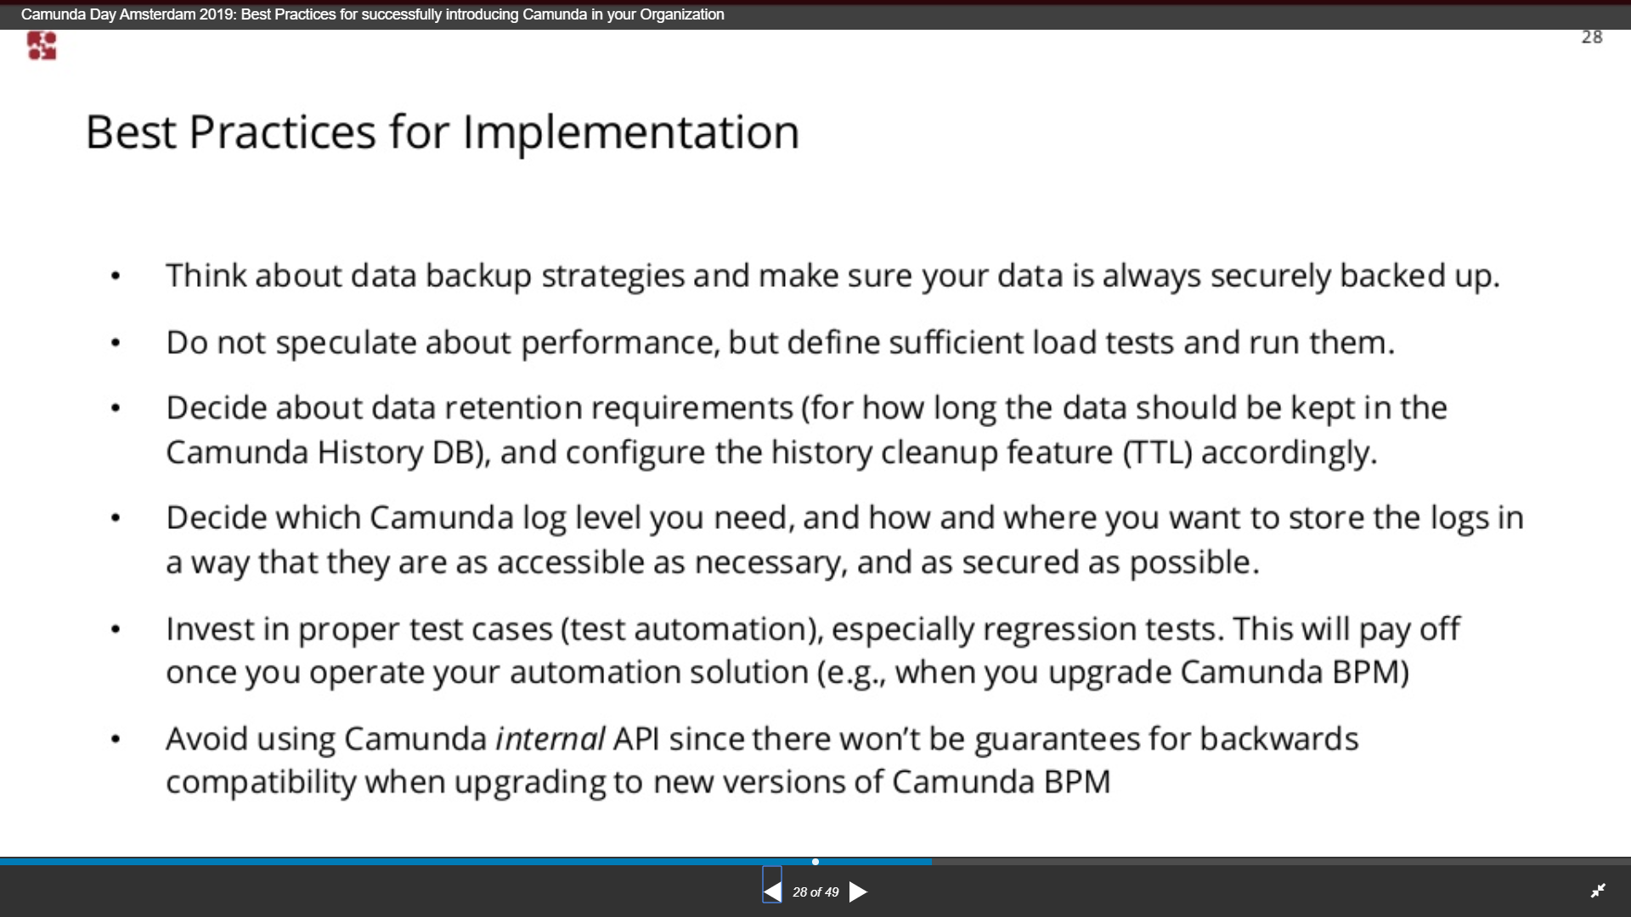

Process Patterns

1. Procedural Patterns
2. Advanced Branching and Synchronization Patterns
3. Structural Patterns
4. Multiple Instance Patterns
5. State Based Patterns
6. Cancellation Patterns

Procedural Patterns

##### Sequence Pattern

##### Simple Merge Pattern

##### Parallel Split and Synchronization Pattern

Advanced Branching and Synchronization Patterns

##### Multiple Choice and Synchronizing Merge Patterns

Structural Patterns

##### Arbitrary Cycles Pattern

Additional Topics

Camunda 8 Demo

Use cases for parallel calls and group assignments.

Use case for Saga Decentralized Orchestration

Multi Tenancy

Camunda Enterprise Optimize (Monitoring etc.,)

Camunda Application Migration from version 6 community to 7 Enterprise

Different deployment Strategies